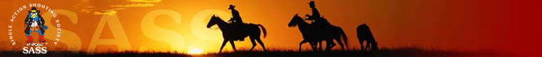
Virginia City Marshals
Liability Release and Disclaimer
2019 – 2020 Season

Name: __________________________________________ SASS #: _______________
Alias: ___________________________________________ NRA #: ________________
Email address: ____________________________________________________________

The sport of Cowboy Action Shooting consists of shooting targets, many of which are steel, with live, all-lead ammunition. All ammunition must be loaded to SASS (Single Action Shooting Society) specifications for the safety of participants and spectators. If you are uncertain of your ammunition speed or type, contact the match director. Participation in this sport is done so with the knowledge that shooting firearms is inherently dangerous and it is impossible to guarantee completely that occasional lead splatter will not enter the shooting or spectator area. Every precaution is taken at the National Rifle Association (NRA) range to make this a safe shoot. However, we cannot be held responsible for injuries or property damage which may be caused during a shooting match. All participants assume the risks normally attendant to loading and shooting guns. ALL participants and observers must wear hearing and eye protection during the match. The club is not responsible for personal injuries or damage to vehicles, equipment, firearms, or clothing. Unsafe behavior, improper use of firearms, failure to obey safety instructions, use of alcohol or drugs (illegal or performance hampering prescription or over-the-counter), failure to respond to any safety command will result in immediate disqualification from the match and an escort off the shooting grounds.
Signing this disclaimer indicates that you agree with the above conditions and that you voluntarily waive all claims for personal injury including death and or damages to property and that you waive the right to hold the Virginia City Marshals, its officers, agents, and match personnel liable for any such injuries or death and or damages to property which may be happen while participating in this shooting event. This is to include the action of third parties.

Signed: ____________________________________________ Date: ________________
Minor? (Y/N): ________ Parent/Guardian signature required for minors under 18.
Parent/Guardian: ____________________________________ Date: _______________

Document Revision Date: 2 January 2020

